Interoperability Info Sheet for Health Plan

The Centers for Medicare and Medicaid Services (CMS) established the Interoperability and Patient Access rule to support the 21st Century Cures Act and executive Order in 2019.
Purpose:
As a means “to improve the quality and accessibility of information that Americans need to make informed health care decisions, including data about health care prices and outcomes, while minimizing reporting burdens on affected health care providers and payers.”
In support of the Century Cures Act, West Virginia Senior Advantage is working along with its respective vendors to provide you, the member, with greater access to your health insurance data. As a part of the first phase of this initiative, West Virginia Senior Advantage and its vendors are providing members with the ability to connect to their health insurance data using standardized Patient Access through secure interfaced applications.
Privacy & Security
Application services used for the Century Cures Act, are not owned by West Virginia Senior Advantage
They may collect information about you and your health. Make sure to review all privacy policies.
Security and privacy are important. Consider the following questions:
- What health information the app will collect
- What other information the app will collect
- If your identity will be stored
- If and how the app will use your information
- If and how the app will share your information
- Why and with whom the app will share your information
- If the app will sell your information
- If and how the app will let you know about changes to its policies
- If and how you can limit the app’s use of your information
- If and how the app protects your information
- How using this app could affect others, such as your family
- If and how you can see your information and correct any mistakes
- How to send complaints to the app
- How to delete your account or information
- If and how you can stop the app from seeing or using your information
- If and how the app will let you know if there is a security breach

Sensitive Health Information:
You must first allow us to give apps sensitive health information about:
- Substance use disorder | - HIV/AIDS | - Psychotherapy
- Reproductive health | - Communicable disease | - Other sensitive health information

This information will not be released without your permission.

Important Links
The Health Insurance Portability and Accountability Act (HIPPA) is a federal law that protects health information.
https://www.hhs.gov/hipaa/for-individuals/guidance-materials-for-consumers/index.html
If you believe an application has misused your information
- You have the right to file a complaint with OCR under HIPAA, by visiting:
https://www.hhs.gov/hipaa/filing-a-complaint/index.html
- Individuals can file a complaint with OCR using the OCR complaint portal:
https://ocrportal.hhs.gov/ocr/smartscreen/main.jsf
- Individuals can file a complaint with the FTC using the FTC complaint assistant:
https://www.ftccomplaintassistant.gov/#crnt&panel1-1
- The FTC provides information about mobile app privacy and security for consumers here:
https://www.consumer.ftc.gov/articles/0018-understanding-mobile-apps

Next Steps:
Member Registration:
- Member Portal Account Creation
- FHIR Eye Access

- Complete your Member Portal account first by going to:
https://optummember.prod.healthaxis.net/member/fhir
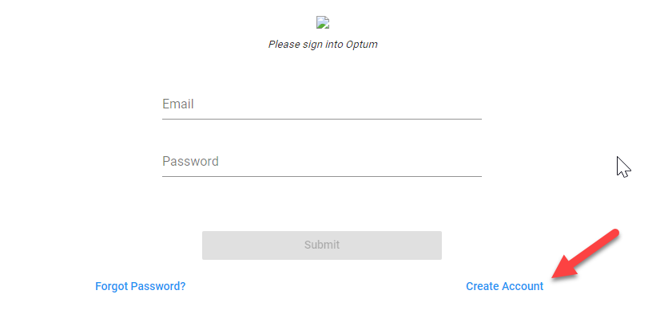
Select Create Account

Complete all the fields in the registration screen
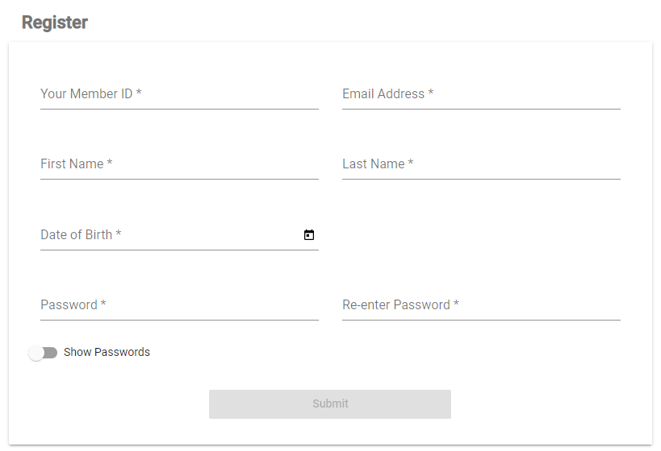
Informational Only
  - Password - must contain at least eight characters; including at least one upper case letter, at
least one number and at least one special character; and select [Submit]

Note - Member does not need to be logged into the Member Portal to access health information via FHIREYE

- Member Registration for FHIREYE
- Enter this browser address: https://APP.FHIREYE.COM/#/login/register
- Select Sign Up
Enter your email address and password (from Step 1) and select register
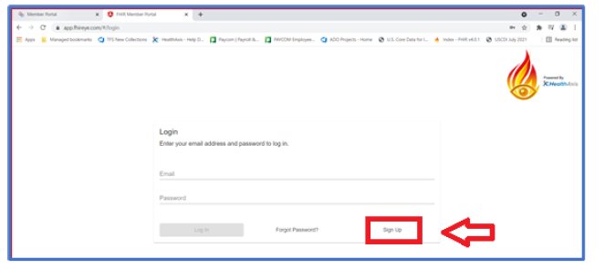
- You will be prompted to Register as a new member for FHIR Eye:
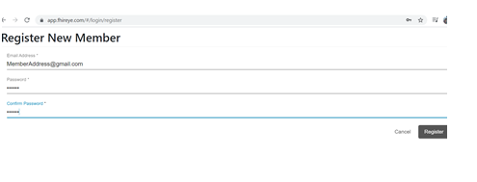

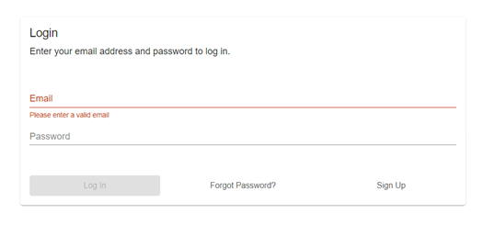
- Re-enter your Email address and the password you have just created (from step 1) and
select Log In

- Once you are logged in the next step is to authorize FHIREYE to connect to your Health Information by entering the following:
- Your Name
- Member Portal URL please enter https://optummember.prod.healthaxis.net
- Select the Authorize button
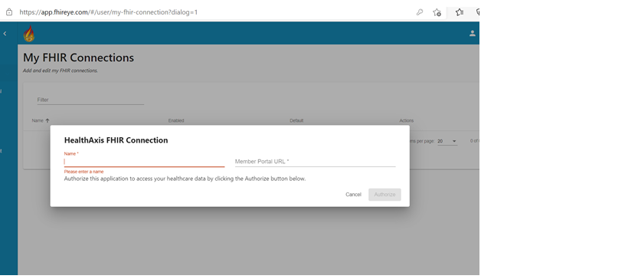

- To complete the registration, please enter your email address and password. Select Log in and Allow under the Terms if you agree with the Terms, allowing access to your personal health information for your visibility.
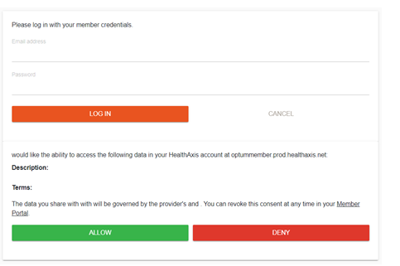

This completes the registration process.
Once you Allow the FHIREYE browser access, you will see the webpage load your health information such as claims, authorizations and pharmacy related materials.
Viewing Your Information:
From the main page, use the left-hand navigation bar to select from available information sets:
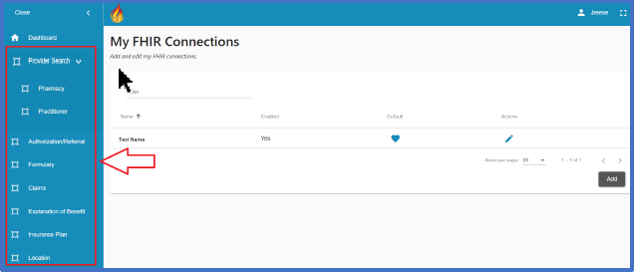

Navigate through your medical records by using the tabs on the left side of the screen, the search tools at the top of each page.

  - View details by clicking on any record.

Thank you.

